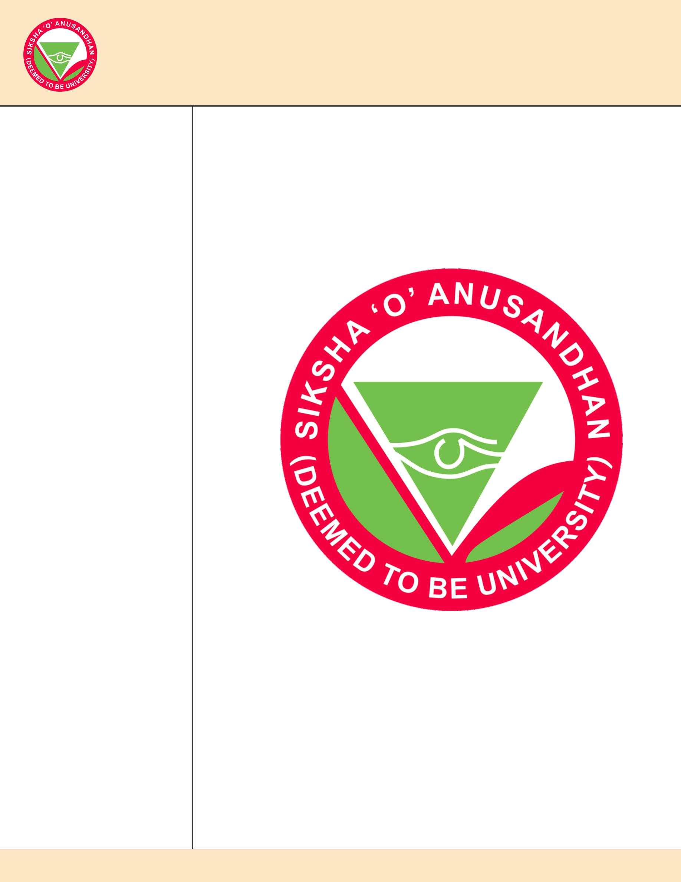
1st Annual Masterclass in Managing Thoracic Diseases

Theme:- Looking Beyond Medical Management

Workshop cum CME- 2019

Department of Oncosciences , IMS & SUM Hospital , Bhubaneswar

Patron in chief

Prof . Manojranjan Nayak

Chief Patron

Prof. Amit Banerjee

Prof. Ashok Kumar Mohapatra

Patron

Prof. Gangadhar Sahoo

Prof. Pusparaj Samantasinghar

Organizing chairman

Prof. Manoranjan Pattnaik

Co Organizing chairman

Dr. R. N Mania

Dr. Prasant Raghab Mohapatra

Dr . Narayan Mishra

Dr . Pravati Dutta

Organizing secretary

Dr. Sourav Mishra

Dr. Sunil Agrawala

Joint Organizing secretary

Dr. Amitabh Jena

Dr. Praduymna Sahoo

Co Organizing secretary

Dr.Soumya Surat Panda

Dr. Priyanka Samal

Dr. Hemalata Das

Conference Convener

Dr. Bana Bihari Mishra

Scientific Committee

Dr. Manoj Sahoo

Dr. Debasis Sahu

Dr. Kastari Bhardwaz

Dr. Rakhi Luddam

Dr. Sandeep Mohanty

Dr. Chira Khadanga

Dr. Prakash Samal

Reception Committee

Dr. Banani Jena

Dr. Santosh Singh

Finance & Treasurer

Dr. Saroj Panda

Miss Twinkle Rou

Logistic & Transport Support

Dr . Premanand Pattanik

Mr. Abhijit Upadhaya

Mr Subasis Nayak

Registration

Dr. Satya sundar Mohapatra

Mr. Debi Mohanty

Dr. Swapna Sagar

Media

Mr. Paresh Das

Dr. Lingaraj Rath

HR & IT

Mrs. Aurolipy Das

Mrs . Radha Agrawala

Contact: +91-7381523459, 8280080712, Email: thoracicmasterclassbbsr@gmail.com, Web: www.thoracicmasterclassbbsr.com

